**The University of New Mexico**

**School of Engineering**

**Electrical and Computer Engineering Department**

**ECE 535 Satellite Communications**

**Student Name: Scott Nguyen**

Module # 8: Problems 8.3, 8.4, 8.5, 8.6, 8.8, 8.9

Summer 2025

**Prof. Tarief Elshafiey**

8.3. Why is it desirable to down convert the satellite TV signal received at the antenna?

The satellite TV signal received at the antenna is downconverted to a lower frequency range, typically 950 to 1450 MHz, by the low-noise block (LNB). This downconversion is desirable because it enables the use of a low-cost coaxial cable as the feeder to the indoor unit, making the system more economical.

8.4. Explain why the LNA in a satellite receiving system is placed at the antenna end of the feeder cable.

The LNA (low-noise amplifier) in a satellite receiving system is placed at the antenna end of the feeder cable in order to maintain a satisfactory signal-to-noise ratio. If the LNA were placed at the indoor end of the cable, it would also amplify the cable's thermal noise, which would be undesirable.

8.5. With the aid of a block schematic, briefly describe the functioning of the indoor receiving unit of a satellite TV/FM receiving system intended for home reception.

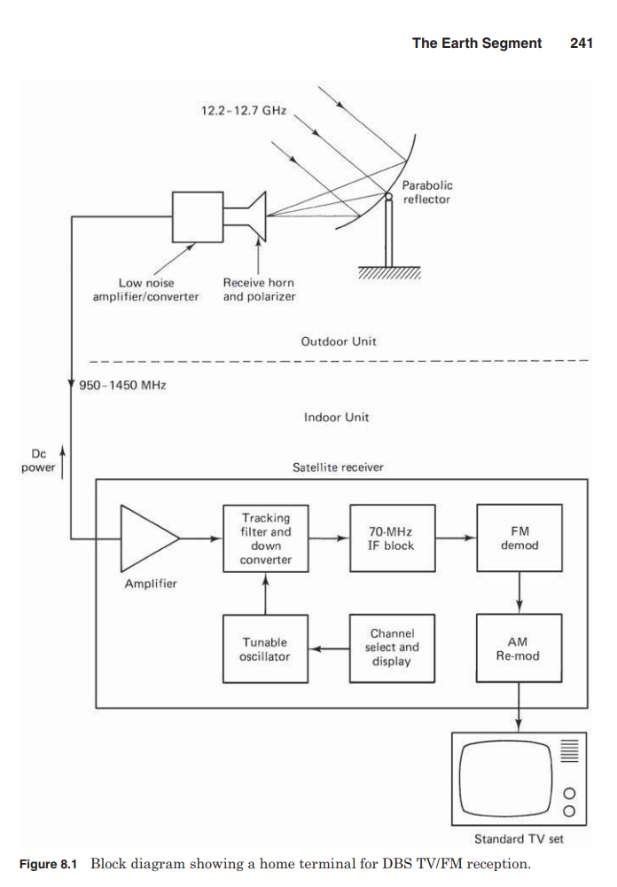The indoor receiving unit of a home satellite TV/FM system, as depicted in the block schematic, begins its operation by taking in a wideband signal spanning 950 to 1450 MHz, which it receives from the outdoor unit. This incoming signal is first routed through an amplifier, where its strength is boosted. Following this initial amplification, the signal enters the tracking filter and downconverter. Here, in conjunction with a tunable oscillator, the specific desired channel is precisely selected and subsequently converted down to a fixed intermediate frequency, most commonly 70 MHz. The channel selection and display component of the system governs the tunable oscillator, allowing users to choose their preferred programming.

Once at the 70-MHz IF, the signal undergoes further amplification within the 70-MHz IF block. As satellite television employs frequency modulation, the amplified IF signal then proceeds to an FM demodulator, where the raw video and audio baseband signals are extracted. These demodulated signals are then re-modulated into an AM (amplitude modulated) VSSB (vestigial single sideband) format, preparing them for compatibility with standard home television sets. This final VSSB signal is then fed into one of the TV's VHF or UHF channels, completing the reception process. The indoor unit also manages the DC power supply to the external components of the system.

8.6. In most satellite TV receivers the first IF band is converted to a second, fixed IF. Why is this second frequency conversion required?

The second frequency conversion in most satellite TV receivers, taking the first IF band to a fixed second IF, is necessary to simplify the task of the tracking filter. This process narrows down the frequency range, making channel selection more precise and efficient, especially with polarization interleaving where alternate channels are well separated in frequency.

8.8. Describe and compare the MATV and the CATV systems.

The Master Antenna TV (MATV) system is designed to provide satellite TV/FM channel reception to a small group of users, such as tenants in an apartment building. It utilizes a single outdoor unit (antenna and LNA/C) that feeds a number of indoor units. Each user has independent access to all the channels. While only one outdoor unit is needed, separate LNA/Cs and feeder cables are required for each sense of polarization. MATV systems typically require a larger antenna (2- to 3-m diameter) compared to single-user systems to maintain a good signal-to-noise ratio at all indoor units. Local programming material cannot be distributed through an MATV system.

The Community Antenna TV (CATV) system also employs a single outdoor unit with separate feeds for each sense of polarization, ensuring all channels are simultaneously available. However, unlike MATV, CATV systems do not have a separate receiver for each user. Instead, all carriers are demodulated in a common receiver-filter system. The channels are then combined into a standard multiplexed signal for transmission over cable to subscribers. In remote areas without cable distribution, the signal can be rebroadcast from a low-power VHF TV transmitter, often using an 8-m antenna for C-band reception. A key difference from MATV is that CATV systems do allow for the distribution of local programming material to subscribers.



8.9. Explain what is meant by the term redundant earth station.

A redundant earth station refers to a system where certain units are duplicated. If a primary unit fails, a duplicate or redundant unit is automatically switched into the circuit to replace it, ensuring continuity of operation.